1. Introduction 2
2. Objective of the Study 2
3. Dataset Description 3
4. Tools and Technologies Used 3
5. Data Cleaning and Preprocessing 4
6. Exploratory Data Analysis and Insights 4
6.1 Brand-wise Price Analysis 4
6.2 Vehicle Condition Distribution 5
6.3 Average Price by Vehicle Condition 5
6.4 Fuel Type and Pricing Trends 5
6.5 Mileage vs Price Relationship 6
7. Key Findings 6
8. Business Implications 6
9. Limitations and Future Scope 7
10. Conclusion 7
10. Appendix - Python Code 8

1. Introduction
The used car market has become an essential segment of the automotive industry, driven by rising new car prices, increased demand for personal mobility, and rapid innovation in vehicle technology. For dealerships, online marketplaces, and resellers, accurately pricing used vehicles is a critical challenge. Pricing too high can reduce demand and inventory turnover, while pricing too low can directly impact profitability.
This project, Used Car Market Pricing Analysis, focuses on understanding how various factors such as brand, vehicle condition, fuel type, mileage, and age influence the selling price of used cars. By applying data analysis techniques using Python, the study aims to extract actionable insights that can support data-driven pricing strategies for used-car businesses.

2. Objective of the Study
The primary objective of this project is to analyze the used car market and identify the key factors that influence vehicle pricing. Specifically, the analysis aims to:
- Understand how brand reputation impacts average selling prices.
- Examine the role of vehicle condition in determining market value.
- Analyze the effect of fuel type on pricing trends.
- Study the relationship between mileage and price.
- Support used-car dealerships and online marketplaces in making informed, profit-oriented pricing decisions.

3. Dataset Description
The dataset used for this project contains information about cars listed for sale. Each row represents an individual car listing, while the columns capture its attributes. Key attributes include:
- Brand – Manufacturer of the vehicle (e.g., BMW, Toyota, Tesla).
- Year – Manufacturing year of the vehicle.
- Mileage – Distance driven by the car.
- Engine Size – Engine displacement in liters.
- Fuel Type – Petrol, diesel, hybrid, or electric.
- Transmission – Manual or automatic.
- Condition – New, like new, or used.
- Price – Selling price of the vehicle.
The dataset provides a comprehensive view of both economic and technical factors that influence used car pricing.

4. Tools and Technologies Used
The analysis was performed using the following tools and libraries:
- Python – Core programming language for data analysis.
- Pandas – Used for data loading, cleaning, preprocessing, and aggregation.
- Matplotlib – Used for visualizing trends and comparisons across variables.
- Jupyter Notebook – Interactive environment for exploratory data analysis.
These tools enabled efficient handling of data and clear visualization of insights.

5. Data Cleaning and Preprocessing
Before conducting analysis, the dataset was cleaned and standardized to ensure accuracy and consistency:
- Column names were standardized by removing extra spaces and replacing them with underscores.
- Duplicate records were identified and removed.
- Missing values were checked to ensure data completeness.
- Numeric columns such as year, mileage, engine size, and price were converted to appropriate data types.
- Categorical values were standardized (e.g., fuel type and transmission converted to lowercase, brand names formatted consistently).
- A new feature, Car Age, was created by subtracting the manufacturing year from the current year (2025).
These steps ensured that the dataset was reliable and ready for analysis.

6. Exploratory Data Analysis and Insights

6.1 Brand-wise Price Analysis
The analysis of average selling price by brand revealed that premium brands such as BMW, Tesla, and Mercedes command significantly higher prices compared to mass-market brands like Toyota and Honda.
Insight:
Premium brands benefit from strong brand perception, advanced features, and customer trust, allowing dealerships to maintain higher base prices without significantly affecting demand. This highlights the importance of brand-based pricing strategies.

6.2 Vehicle Condition Distribution
Most of the listings in the dataset fall under the "Used" category, followed by "Like New" and "New" vehicles.
Insight:
The high availability of used vehicles suggests intense competition in this segment. Dealers operating in this category must adopt competitive pricing and value-based differentiation to attract buyers.

6.3 Average Price by Vehicle Condition
When analyzing average price by condition, "Like New" vehicles were observed to have the highest average selling price, even higher than some new vehicles.
Insight:
This suggests that buyers perceive strong value in vehicles that offer near-new condition at a lower price than brand-new models. Pricing decisions should therefore consider condition in combination with brand, mileage, and features rather than condition alone.

6.4 Fuel Type and Pricing Trends
The analysis showed that diesel, hybrid, and electric vehicles tend to have higher average prices compared to petrol vehicles.
Insight:
This reflects increasing market demand for fuel-efficient and environmentally friendly vehicles. Dealerships can leverage this trend by applying premium pricing to alternative fuel vehicles, especially in urban and environmentally conscious markets.

6.5 Mileage vs Price Relationship
Mileage was grouped into ranges to analyze its effect on pricing. The relationship between mileage and price was found to be non-linear.
Insight:
Some higher-mileage vehicles still command higher prices due to strong brand reputation, superior build quality, or advanced technology. This confirms that mileage alone should not be used as a standalone pricing metric; it must be evaluated alongside brand, model, and fuel type.

7. Key Findings
- Premium brands such as BMW, Tesla, and Mercedes exhibit higher average selling prices.
- Vehicle condition significantly influences pricing, with "Like New" vehicles commanding strong premiums.
- Fuel type plays an important role, with diesel, hybrid, and electric vehicles showing higher market value.
- Mileage affects pricing, but its impact varies depending on brand and vehicle category.
- The used car segment has the highest inventory concentration, indicating stronger competition and the need for strategic pricing.

8. Business Implications
The insights from this analysis provide several practical benefits for used-car businesses:
- Helps establish brand-based base pricing strategies.
- Supports condition-based and fuel-type-based price differentiation.
- Assists in identifying premium pricing opportunities for alternative fuel vehicles.
- Enables smarter mileage-based discounting without undervaluing high-quality vehicles.
- Improves inventory planning and profitability by aligning prices with market demand.

9. Limitations and Future Scope
While the analysis provides valuable insights, it has certain limitations:
- The dataset may not capture regional demand variations.
- External factors such as market trends, seasonal demand, and economic conditions were not considered.
- Advanced machine learning models were not applied.
Future enhancements may include:
- Building predictive pricing models using regression or machine learning.
- Incorporating location-based and time-based pricing trends.
- Adding features such as owner history and accident records for more accurate valuation.

10. Conclusion
This project successfully demonstrates how data analysis can uncover critical pricing patterns in the used car market. By understanding the influence of brand, condition, fuel type, and mileage, dealerships and marketplaces can move from intuition-based pricing to data-driven decision-making. The findings highlight that used car pricing is multi-dimensional and requires a balanced evaluation of multiple factors to maximize both sales volume and profitability.

10. Appendix - Python Code
This appendix contains the complete Python source code used for the implementation, analysis, and visualization in this project.

import pandas as pd
import matplotlib.pyplot as plt
# Visualization settings
plt.style.use("default")

# Load the dataset
df = pd.read_csv(r"C:\Users\LENOVO\Desktop\Python Project\car_price_prediction_.csv")
# Using raw string (r"") to prevent Python from interpreting backslashes as escape characters

# Preview data
df.head()

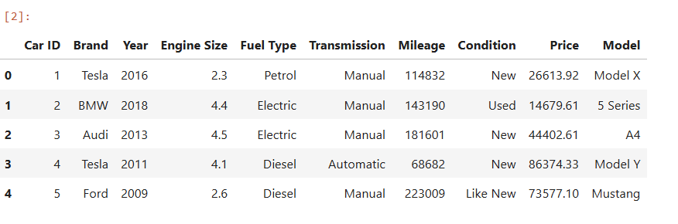
# Dataset shape
df.shape
# Data types
df.info()

# Summary statistics
df.describe(include="all")

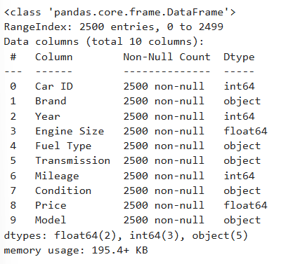

# Standardizing column names by replacing spaces with underscores for consistency
df.columns = df.columns.str.strip().str.replace(" ", "_")
df.columns
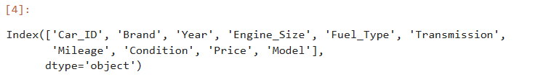

df.isnull().sum()

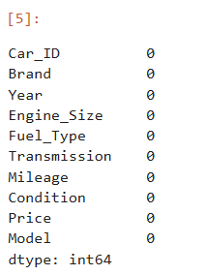

df.duplicated().sum()

# Remove duplicates if any
df.drop_duplicates(inplace=True)
df.duplicated().sum()

# Remove duplicates if any
df.drop_duplicates(inplace=True)
# Standardize column names
df.columns = df.columns.str.strip().str.replace(" ", "_")

# Standardize categorical values
df["Fuel_Type"] = df["Fuel_Type"].str.lower()
df["Transmission"] = df["Transmission"].str.lower()
df["Condition"] = df["Condition"].str.lower()
df["Brand"] = df["Brand"].str.title()

# Create car age feature
CURRENT_YEAR = 2025
df["Car_Age"] = CURRENT_YEAR - df["Year"]

avg_price = df.groupby("Brand")["Price"].mean().sort_values(ascending=False)
top5_brands = avg_price.head(5)

plt.figure()
top5_brands.plot(kind="bar")

# Zoom Y-axis to highlight small differences
plt.ylim(top5_brands.min()*0.98, top5_brands.max()*1.02)

plt.title("Top 5 Brands by Average Price")
plt.xlabel("Brand")
plt.ylabel("Average Price")
plt.show()
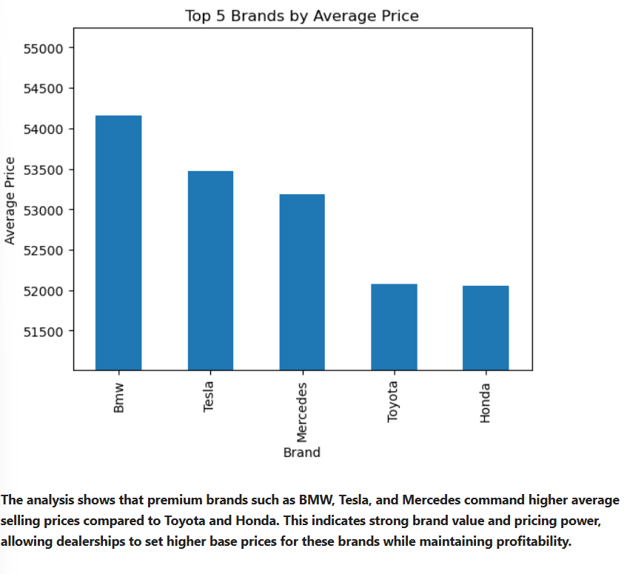

condition_count = df["Condition"].value_counts()

plt.figure()
condition_count.plot(kind="bar")
# Zoom Y-axis to highlight differences
plt.ylim(condition_count.min() * 0.95, condition_count.max() * 1.05)

plt.title("Number of Cars by Condition")
plt.xlabel("Car Condition")
plt.ylabel("Number of Listings")
plt.show()

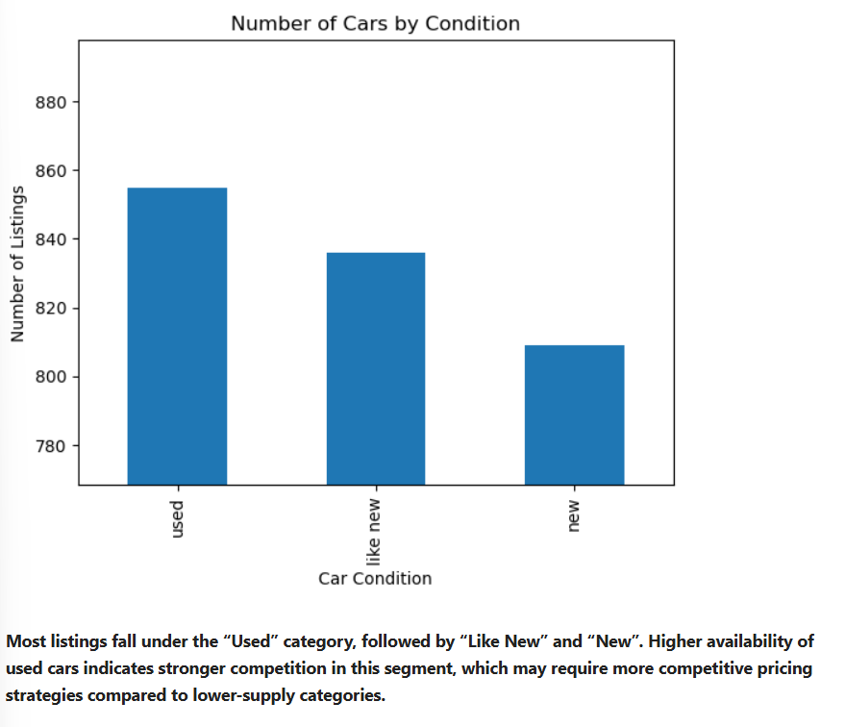
condition_price = df.groupby("Condition")["Price"].mean()
order = ["used", "like new", "new"]
condition_price = condition_price.reindex(order)
plt.figure()
condition_price.plot(kind="bar")
plt.ylim(condition_price.min()*0.95, condition_price.max()*1.05)
plt.title("Average Selling Price by Car Condition")
plt.xlabel("Car Condition")
plt.ylabel("Average Price")
plt.show()
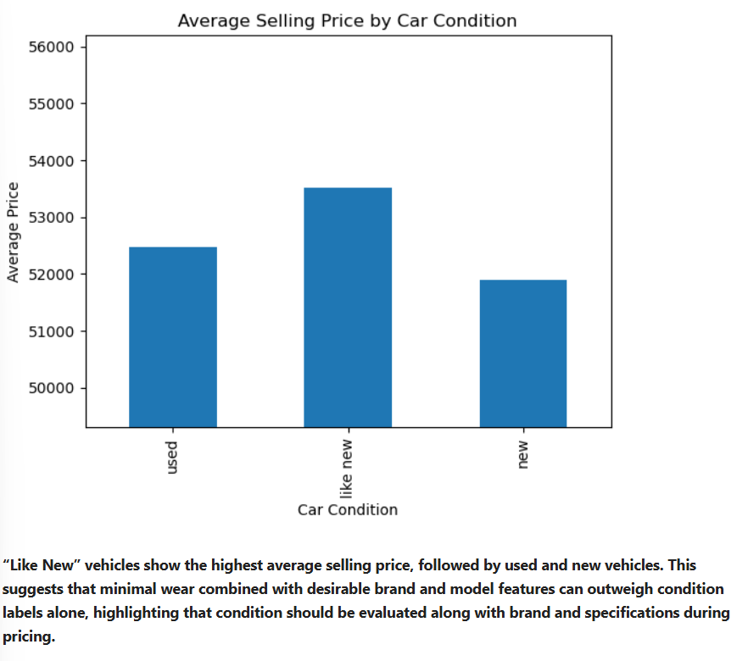
fuel_price = df.groupby("Fuel_Type")["Price"].mean().sort_values()
plt.figure()
fuel_price.plot(kind="bar")
plt.ylim(fuel_price.min()*0.95, fuel_price.max()*1.02)
plt.title("Average Selling Price by Fuel Type")
plt.xlabel("Fuel Type")
plt.ylabel("Average Price")
plt.show()

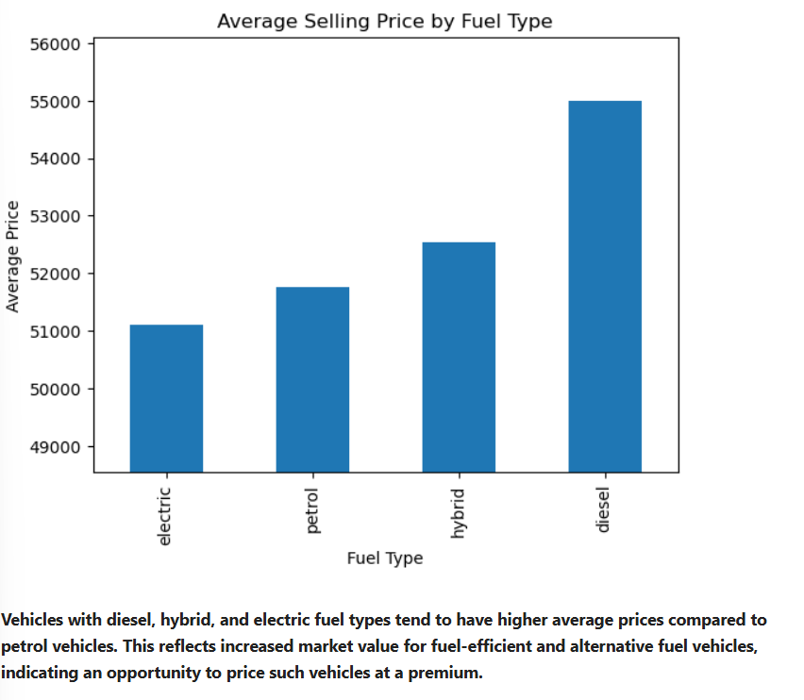
# Create mileage bins
df["Mileage_Band"] = pd.cut(
df["Mileage"],
bins=10
)

# Calculate average price per mileage band
mileage_price = df.groupby("Mileage_Band", observed=False)["Price"].mean()

plt.figure()
plt.plot(mileage_price.index.astype(str), mileage_price.values, marker="o")

plt.title("Average Price by Mileage Range (Influenced by Brand & Model Mix)")
plt.xlabel("Mileage Range")
plt.ylabel("Average Price")
plt.xticks(rotation=45)
plt.show()

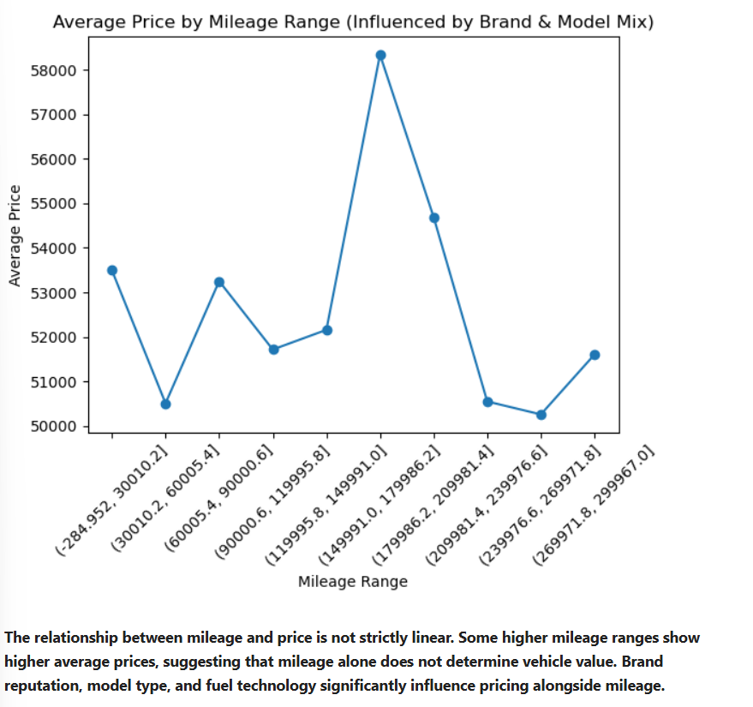

Project Name: Used Car Market Pricing Analysis

